**GLA UNIVERSITY MATHURA**

**Department of CEA**

Operating Systems Lab

**Lab Record File**

(2024-25)

*for*

3rd Semester

**Submitted By:**

Manish Bhardwaj

B. Tech CS [AIML & IoT]

(2315510116)

Section: CB(26)

**Submitted To:**

(Lab Faculty)

**LINUX COMMANDS WITH THEIR EXAMPLES**

1. **cal command :-** The cal utility displays a simple calendar in traditional format. If arguments are not specified, the current month is displayed.

Execution:

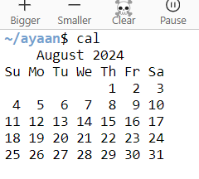

Examples:-

1. **Display the Current Month’s Calendar**:

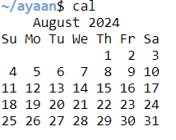

**2.Display a Specific Month and Year**:

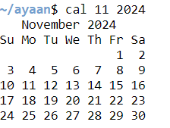

**3.Display a Three-Month Calendar View:**

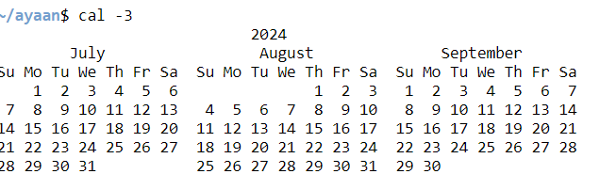

1. date command :- The date command in Linux is used to display or set the system date and time. It can show the current date and time in various formats, and you can also use it to set the system's date and time.

Execution :

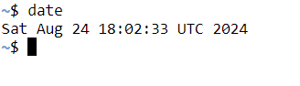

Examples:-

1. **Display Only the Current Date:-**

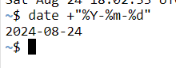

1. **Display the Month and Year:-**



1. **Display Yesterday's Date:-**

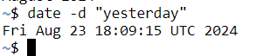

1. ls command:- The ls command in Linux is used to list the contents of a directory. It displays files, directories, and various attributes. The ls command is one of the most commonly used commands for navigating the file system.

Execution:



Examples:-

1. **List All Files, Including Hidden Files:-**

2. **List Files in a Specific Directory:-**

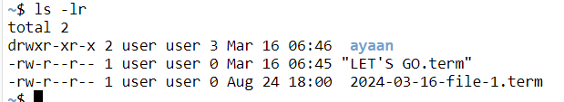**3.List Files in Reverse Order:-**

1. Head command :- The head command in Linux is used to display the first few lines of a file or output from a command. By default, it shows the first 10 lines, but you can customize the number of lines displayed.

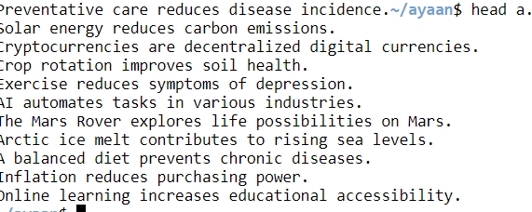Execution:

Examples:-

**1.Display the first 5 lines of a file**:

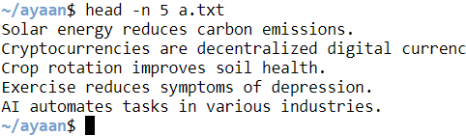

**2.Display the first 20 bytes of a file**:



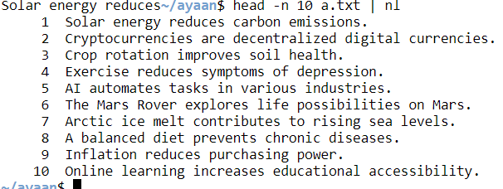 3.**Display the first 10 lines of a file with line numbers**:

1. Tail command:- The tail command in Linux is used to display the last part of a file or stream of data. By default, it shows the last 10 lines of a file.

Execution:

